Dedication to the Year OF DEFENDER OF THE FATHERLAND

INFORMATION MESSAGE

RUSSIAN ACADEMY OF SCIENCES
VORONEZH STATE TECHNICAL UNIVERSITY

MILITARY EDUCATIONAL AND SCIENTIFIC CENTER OF THE AIR FORCE "PROFESSOR N.E. ZHUKOVSKY AND Y.A. GAGARIN AIR FORCE ACADEMY" (VORONEZH)
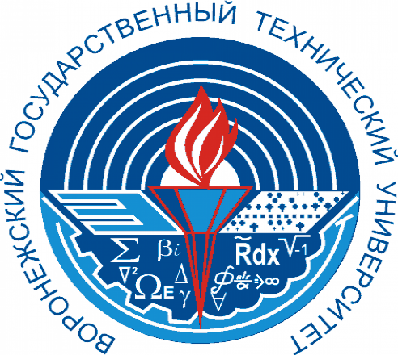

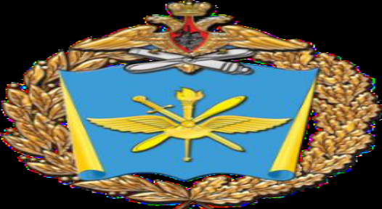
VIII
INTERNATIONAL SCIENTIFIC AND PRACTICAL CONFERENCE
"COMPLEX PROBLEMS OF TECHNOSPHERE SECURITY»

25 december 2025

VORONEZH

CONDITIONS FOR PARTICIPATION IN THE CONFERENCE

Dear colleagues! We invite you to take part in
VIII International scientific and practical conference «Complex problems of technosphere security»

December 25, 2025
Voronezh State Technical University
The Organizing Committee of the conference asks you
to send applications, short presentations and articles (from 4 to 10 pages). Participation by correspondence in 2025. The certificate and diploma in 2025 are provided to participants who have sent a short presentation on the article
before December 23, 2025.

Based on your applications and articles, the program of the VШ international conference will be formed and will be posted on the WEBSITE: http://www.б-б.su (articles submitted before December 23 will be included), and a collection of conference materials has been prepared with the registration of articles in the bibliographic database of the RSCI and Yelaiberi, published in February 2026). There is no registration fee.

Conference materials are indexed by ISSN: 2618-9739 of the Russian Federation.
The organizing Committee reserves the right not to include articles that do not correspond to the scientific direction of the conference.

Plagiarism check is carried out by RIO Voronezh state technical University!

OFFICIAL LANGUAGES OF THE CONFERENCE
Russian and English.

Conference Organizing Committee
Executive Secretary of the Conference
Zvyagintseva Alla Vitalievna
Mobile phone number. +7 950-750-10-62
E-mail: zvygincevaav@mail.ru

The requirements for the design of materials for publication and the application form for participation in the conference are presented in the files attached to this letter.:
1. Information about the main directions of the conference and the application form (Appendix No. 2. Sample design of the article (Appendix No. 2).
3. Sample design of the presentation (Appendix No.

You can receive the materials of the I-VII International Scientific and Practical Conferences "Complex problems of technosphere security" for 2014-2023 by e-mail, by sending an application to our address or on the website (archive):
WEBSITE:
http://www.б-б.su Remote conducting is online. Participation is free of charge, subject to a brief presentation of your article, which will be published on the conference website. Articles will be published in the materials only after passing the plagiarism!
If you have any questions, please contact this email address, phone number, or website.

SCIENTIFIC COMMITTEE OF THE CONFERENCE

Drozdov Igor Gennadievich - Doctor of Technical Sciences, Professor, Vice-rector for Cooperation with Industrial Enterprises of VSTU (Voronezh, Russia).
Nikolay Alekseevich Severtsev – military equipment design Engineer, Honored Worker of Science and Technology of Russia, USSR State Prize Winner, Russian Government Prize winner in the field of science and education, Doctor of Technical Sciences, Professor, full member of the public scientific academies (Russian Academy of Cosmonautics named after K.E. Tsiolkovsky, Academy of Problems Russian Academy of Natural Sciences), President of the V.F. Utkin International Foundation of Scientists and Engineers, Vice Admiral Engineer, Head. Branch of the Department of Nonlinear Analysis and Security Problems of the A.A. Dorodnitsyn Computing Center, Russian Academy of Sciences (Moscow Moscow, Russia).
Ivanov Nikolay Igorevich – Honored Scientist of the Russian Federation, Doctor of Technical Sciences, Professor of the D.F. Ustinov Baltic State Technical University Voenmeh, Editor-in-chief of the abstract journal "Noise", Deputy Editor-in-Chief of the international journal "International Journal of Acoustics and Vibration", member of the Supreme Environmental Council of the State Duma (St. Petersburg, Russia).
Vladimir Arkadyevich Devisilov – Candidate of Technical Sciences, Associate Professor, Bauman Moscow State Technical University, laureate of the President of the Russian Federation Award in Education, laureate of the Government of the Russian Federation Award in Education, Chairman of the Federal Educational Institution "Technosphere Safety and Environmental Management", Editor-in-chief of the journal "Safety in the Technosphere" (Moscow, Russia).
Lutovac Mitar – Academician, Professor, Dr. (Union - Nikola Tesla University, Belgrade, Serbia and Faculty of Management, Herceg Novi, Montenegro).
Mirjanic Dragolyub is an academician of the Academy of Sciences and Arts of the Republika Srpska, Professor at the University of Banja Luka (Banja Luka, Republika Srpska).
Tertyshnikov Alexander Vasilyevich - Doctor of Technical Sciences, Head of Scientific Associate Professor, Federal State Budgetary Institution "Institute of Applied Geophysics named after Academician E.K. Fedorova" (Moscow, Russia).
Luzzi Sergio is a professor at the University of Florence (Florence, Italy). Honorary Visiting Professor, Ural State University (UrGUPS), Yekaterinburg. Scientific Director of the OSHNET SCHOOL for Higher Certified Education in Occupational Health and Safety (Turkey). Director of the International Institute of Sound and Vibration.
Eleonora Carletti is Director of the Institute of Agricultural and Earthmoving Machinery (IMAMOTER-CNR) and Head of the IMAMOTER research Group (Ferrara, Italy).
Roessner Frank is a professor, Head of the Department of Technical Chemistry at the Oldenburg University. Karl von Osetsky (Oldenburg, Germany).
Gusev Alexander Leonidovich is the editor-in-chief of the International Scientific Journal Alternative Energy and Ecology (ISJAEE), Academician of the State Royal Academy of Sciences of Serbia, Director General of the Scientific and Technical Center "TATA" (Sarov, Russia).
Saechnikov Vladimir Alekseevich - Doctor of Physical and Mathematical Sciences, Professor, Head of the Department of Physics and Aerospace Technologies, Faculty of Radiophysics and Computer Technologies, BSU, Scientific Head of the Center for Aerospace Education of the Belarusian State University (Minsk, Republic of Belarus).
Mikhail Mikhailovich Kugeyko - Doctor of Physics. Candidate of Mathematical Sciences, Professor of the Department of Quantum Radiophysics of Optoelectronics at the Belarusian State University (Minsk, Republic of Belarus).
Abdullaev Sabur Fuzailovich – Doctor of Physical and Mathematical Sciences, Professor, Head of Laboratory of Atmospheric Physics, laureate of the S.U. Umarov Academy of Sciences, S.U. Umarov Institute of Physics and Technology of the National Academy of Sciences of the Republic of Tajikistan (Dushanbe, Republic of Tajikistan).
Normatov Igor Sherovich – Corresponding member. National Academy of Sciences of the Republic of Tajikistan, Doctor of Chemical Sciences, Professor, Head of the Department of Meteorology and Climatology, Tajik National University (Dushanbe, Republic of Tajikistan).
Trofimov Viktor Titovich - Dr. geol.- Doctor of Sciences, Professor, Academician of the Russian Academy of Natural Sciences and the Russian Academy of Sciences of Higher Education, Honored Scientist of the Russian Federation, laureate of the USSR and Russian State Prizes, Lomonosov Prizes of the 1st degree of Moscow State University for scientific work and for pedagogical activity, Head of the Department of Engineering and Environmental Geology of the Faculty of Geology of Lomonosov Moscow State University (Moscow, Russia).
Vasiliev Andrey Vitalievich - Doctor of Technical Sciences, Professor, Head of the Department of Chemical Technology and Industrial Ecology, Samara State Technical University, Honorary Worker of Higher Professional Education of the Russian Federation (Samara, Russia).
Mikhailov Alexander Nikolaevich - Doctor of Technical Sciences, Professor, Head of the Department of Mechanical Engineering Technology, Donetsk National Technical University (DonNTU), Chairman of the International Union of Machine Builders (Donetsk, Donetsk People's Republic, Russia).
Galina Khromova, Doctor of Technical Sciences, Professor of the Department of Electric Transport and High-Speed Electric Rolling Stock, Akmal Ikramov Tashkent Institute of Railway Engineers (TASHIIT) (Tashkent, Republic of Uzbekistan).
Strogova Alexandra Sergeevna - Candidate of Technical Sciences, Associate Professor, Deputy Head of the Main Department for Science, beginning Department of Organization and Support of Innovation Activities, Belarusian State University (Minsk, Republic of Belarus).

CONFERENCE ORGANIZING COMMITTEE

Valery Nebolsin, Doctor of Technical Sciences, Professor, Dean of the Faculty of Radio Engineering and Electronics, Head of the Department of Solid-State Electronics at VSTU (Voronezh, Russia) – Chairman.
Dmitry Vladimirovich Zhuravlev – Candidate of Technical Sciences, Associate Professor, Head of the Department of Radioelectronic Devices and Systems at VSTU (Voronezh, Russia) – Co-Chairman.
Kravtsov Evgeny Vladimirovich – Doctor of Technical Sciences, Associate Professor, Head of the Educational and Methodological Center Military Training and Scientific Center of the Air Force Air Force Academy named after Professor N.E. Zhukovsky and Yu.A. Gagarin (Voronezh, Russia) - Co-Chairman.
Zibrova Nadezhda Vladimirovna – Candidate of Geographical Sciences, Associate Professor, Senior Researcher. An employee of the 452nd Scientific Research Laboratory (NIL) of the Central Research Institute of the Military Training and Scientific Center of the Air Force Air Force Academy named after Professor N.E. Zhukovsky and Yu.A. Gagarin (Voronezh, Russia) – Co-Chairman.
Kirnosov Sergey Leonidovich – Candidate of Technical Sciences, Head of the 11th Department of Theoretical Hydrometeorology, Military Training and Research Center "Air Force" Air Force Academy named after Professor N.E. Zhukovsky and Yu.A. Gagarin" (Voronezh, Russia).
Kuznetsov Ilya Evgenievich – Doctor of Technical Sciences, Professor, Head of 12 Departments of Hydrometeorological Support Military Training and Research Center "Air Force "Air Force Academy named after Professor N.E. Zhukovsky and Yu.A. Gagarin" (Voronezh, Russia).
Gedzenko Denis Viktorovich - Candidate of Technical Sciences, Associate Professor, Deputy Head of the 11th Department of Theoretical Hydrometeorology, Military Training and Research Center "Air Force" Air Force Academy named after Professor N.E. Zhukovsky and Yu.A. Gagarin" (Voronezh, Russia).
Kochetova Zhanna Yuryevna – Doctor of Geographical Sciences, Associate Professor 111 of the Department of Radio Engineering Systems and Flight Support Military Training and Research Center "Air Force" Air Force Academy named after Professor N.E. Zhukovsky and Yu.A. Gagarin" (Voronezh, Russia).
Ulshin Igor Ivanovich – Candidate of Physical and Mathematical Sciences, Associate Professor of the 11th Department of Theoretical Hydrometeorology Military Training and Research Center "Air Force" Air Force Academy named after Professor N.E. Zhukovsky and Yu.A. Gagarin" (Voronezh, Russia).
Igor Polikarpovich Rastorguev - Candidate of Geographical Sciences, Associate Professor of the 12th Department of Hydrometeorological Support Military Training and Research Center "Air Force" Air Force Academy named after Professor N.E. Zhukovsky and Yu.A. Gagarin" (Voronezh, Russia).
Alexander Alexandrovich Spiridonov – Candidate of Physical and Mathematical Sciences, Associate Professor of the Department of Physics and Aerospace Technologies of the Belarusian State University (Minsk, Republic of Belarus).
Nikolai Alexandrovich Us - Doctor of Technical Sciences, Professor, member of the Academy of Informatization of Education, Military Training and Scientific Center "Air Force" Militarythe Air Academy named after Professor N.E. Zhukovsky and Yu.A. Gagarin" (Voronezh, Russia).
Mozgovoy Nikolay Vasilyevich - Doctor of Technical Sciences, Professor, Department of Technosphere and Fire Safety at VSTU (Voronezh, Russia).
Viktor F. Asminin, Doctor of Technical Sciences, Professor of the Department of Life Safety and Legal Relations. Honored Professor Voronezh State Forestry Engineering University named after G.F. Morozov (VGLTU) (Voronezh, Russia).
Kurolap Semyon Alexandrovich – Doctor of Geographical Sciences, Professor, Dean of the Faculty of Geography, Geoecology and Tourism, Head. Environment of the VSU, Chairman of the Voronezh Regional Branch of the Russian Geographical Society (Voronezh, Russia).
Irina I. Kosinova, Doctor of Geological and Mining Sciences, Professor, Head of the Department of Ecological Geology at VSU, Academician of the International Academy of Ecology and Life Safety (MANEB) and the Russian Academy of Ecology (Voronezh, Russia).
Alexander Nikolaevich Chukarin - Doctor of Technical Sciences, Professor, Head of the Department "Fundamentals of Machine Design", Honorary Worker of the Higher Professional Education of the Russian Federation, Rostov State University of Railway Transport (RGUPS), Deputy Head. Editor of the Security of Man-made and Natural Systems (Rostov-on-Don, Russia).
Igor Nikolaevich Zapletnikov – Doctor of Technical Sciences, Professor, Head of the Department of Food Production Equipment at Donetsk Tugan-Baranovsky National University of Economics and Trade (DONNUET), Academician of the International Academy of Refrigeration, Honorary Professor DONNUET, Honorary Worker of Science and Technology of the DPR (Donetsk, Donetsk People's Republic, Russia).
Yulia Arkadyevna Omelchuk – Candidate of Chemical Sciences, Associate Professor, Director of the Institute of Nuclear Energy and Industry, Sevastopol State University (SevGU), Certificate of Honor from the Ministry of Science and Higher Education of the Russian Federation (Sevastopol, Russia).
Lidiya Ivanovna Lukina – Candidate of Chemical Sciences, Associate Professor of the Department of Radioecology and Environmental Safety, Institute of Nuclear Energy and Industry, Sevastopol State University (SevGU), Commendation from the Ministry of Science and Higher Education of the Russian Federation (Sevastopol, Russia).
Reliable Lyudmila Ivanovna - Candidate of Geological Sciences.-Min. of Sciences, Associate Professor, Head of A.P. Tarkov Laboratory of Deep Structure, Geodynamics and Seismic Monitoring, VSU, Honorary Diploma of the Russian Academy of Sciences, honorary badge "For Services to VSU", etc. (Voronezh, Russia).
Arseniy V. Mitko – Candidate of Technical Sciences, Associate Professor, D.I. Mendeleev All-Russian Scientific Research Institute of Metrology (VNIIM), St. Petersburg State University, President of the Arctic Public Academy of Sciences (St. Petersburg, Russia).
Vladimir O. Skripachev – Candidate of Technical Sciences, Associate Professor of the Department of Radioelectronic Systems and Complexes of the MIREA - Russian University of Technology (RTU MIREA (Moscow Institute of Radio Engineering, Electronics and Automation)), beginning. Department of Radio Monitoring and Remote Sensing of the Earth (Moscow, Russia).
Oleg Grigorievich Kremenev - Candidate of Technical Sciences, Senior Researcher at the Department of Occupational Safety in Mines, Makeyevka State Research Institute for Safety in the Mining Industry (GBU MAKNII), laureate of the USSR Council of Ministers Award (Makeyevka, Donetsk region, DPR, Russia).
Alexander Petrovich Isachenko – Candidate of Economic Sciences, Associate Professor of the Department of Land Management at the State University of Land Management, Academician of the Russian Academy of Natural Sciences (RAS), Visiting Professor of the scientific and educational expedition "Flotilla of Floating Universities", coordinator of cooperation between the GUZ and partner universities (Moscow, Russia).
Oleg Borisovich Rudakov – Doctor of Chemical Sciences, Professor, Head of the Department of Chemistry and Chemical Technology of Materials at VSTU (Voronezh, Russia).
Zvyagintseva Alla Vitalievna - Candidate of Technical Sciences, Associate Professor of the Department of Chemistry and Chemical Technology of Materials at VSTU, Executive Secretary (Voronezh, Russia).
Lidiya Aleksandrovna Mezhova – Candidate of Geographical Sciences, Associate Professor of the Department of Geography and Tourism, Voronezh State Pedagogical University (VGPU) (Voronezh, Russia).
Maslikova Tatyana Ilyinichna - Candidate of Physical and Mathematical Sciences, Associate Professor at the Voronezh Institute of Economics and Social Management and the Voronezh Branch of the Admiral S.O. Makarov State University of the Marine and River Fleet (GUMRF) (Voronezh, Russia).
Kryukova Natalia Alekseevna – Candidate of Geographical Sciences, Associate Professor Voronezh Branch of the Admiral S.O. Makarov State University of the Marine and River Fleet (GUMRF) (Voronezh, Russia).
Russu Alexander Viktorovich – Candidate of Technical Sciences, Associate Professor of the Department of Timber Science, Voronezh State Forestry Engineering University named after G.F. Morozov (VGLTU) (Voronezh, Russia).

SECRETARIAT:

Zvyagintseva Alla Vitalievna - Candidate of Technical Sciences, Associate Professor of the Department of Chemistry and Chemical Technology of Materials at VSTU, Executive Secretary (Voronezh, Russia).
Maslikova Tatyana Ilyinichna - Candidate of Physical and Mathematical Sciences, Associate Professor at the Voronezh Institute of Economics and Social Management and the Voronezh Branch of the Admiral S.O. Makarov State University of the Marine and River Fleet (GUMRF) (Voronezh, Russia).
Kryukova Natalia Alekseevna – Candidate of Geographical Sciences, Associate Professor Voronezh Branch of the Admiral S.O. Makarov State University of the Marine and River Fleet (GUMRF) (Voronezh, Russia).
Russu Alexander Viktorovich – Candidate of Technical Sciences, Associate Professor of the Department of Timber Science, Voronezh State Forestry Engineering University named after G.F. Morozov (VGLTU) (Voronezh, Russia).
Violetta V. Kulneva is a teacher at VSTU (Voronezh, Russia).

Appendix 1

THE MAIN DIRECTIONS OF THE CONFERENCE

1. Basic, special, critical, information technologies for security. Analysis, assessment, and technologies for reducing natural, man-made, and fire risks.
2. Aerospace, radioelectronic, hydrometeorological and other technologies to ensure and enhance reliability and safety. Systems for monitoring and forecasting the state of the atmosphere, hydrosphere, lithosphere and technosphere.
3. Industrial ecology and chemistry, technologies for cleaning the atmosphere, hydrosphere, lithosphere and technosphere. Low-waste and no-waste production technologies. Technologies, control, diagnostics of the quality and safety of materials in industry, energy, construction and other areas of the technosphere.
4. Safety issues in the application of physical fields, special materials, nanotechnology and critical technologies. Renewable and alternative energy sources. Acoustics.
5. Economic, legal, social, philosophical, medical, psychological and biological aspects of technosphere security. Labor protection.
6. Energy, fire, environmental, chemical, physical and information security of the technosphere and other aspects of critical technologies.
7. The heroic legacy of the past – the path of service to the Fatherland in the present – dedication of the conference.

Application for participation in the VIII International Scientific and Practical Conference "Complex problems of Technosphere security"

December 25, 2025 Voronezh
Full name of the author
(in full)

A country
City
Place of work (study)

Academic degree, title, position
Age up to 35 years or older

Article title

Section name

If the article will be prepared based on the results of a project supported by the Russian Foundation for Basic Research, then specify the project number.

e-mail
Telephone

*If there are several authors, then information about them is filled in in one file and for each in a separate table.
To compile the conference program and create a collection of papers, we ask you to send applications, articles and presentations to our address, and to conduct the remote conference online in 2025.

Appendix 2

ARTICLE DESIGN

To participate in the conference, please send an email: zvygincevaav@mail.ru
applications, articles, presentations:

1. An application for participation in the conference (according to the attached appendix 1) and a presentation (Appendix No. 3) by December 23, 2025.
2. An article of 4 to 10 (full) pages in 1 copy, designed according to the established requirements. The list of references is not less than 5 sources and not more than 20 (Appendix 2). The deadline for submitting articles is January 15, 2026, and the article will not be included in the proceedings of the VIII Conference later.
3. The materials of the articles are published in the author's editorial office, therefore, we draw the attention of the authors of the articles to compliance with the rules of registration of materials.
4. Materials are provided in electronic form marked "for the conference" and should be named by the surname of the first author.
5. The conference organizers will definitely confirm receipt of your work. If there is no response, it is necessary to send the materials again to the email address marked "to the conference".
5. Publication of a collection of articles based on the submitted materials in February 2026.
6. Check for plagiarism.

DESIGN REQUIREMENTS

1. Place the materials on a 4 (210x297) sheet with margins: top – 2.5 cm; bottom – 2 cm; left – 2 cm; right – 2 cm.. The pages should be numbered at the bottom of the sheet, in the middle. The materials should be designed using the WinWord editor (version 2003-2007), ranging from 4 to 15 (full) pages in Times New Roman font size 12. Spacing – 1. Paragraph indentation – 1.25. Text width alignment with automatic hyphenation.
2. The order of registration. The materials must correspond to the structural scheme: UDC, initials of the authors' surnames, abstract and keywords, main text, conclusions, references, name of the organization in Russian. Next, the surname, first name, patronymic of the authors, the title of the article, abstract, keywords and the name of the organization in English.
3. The name should be printed in capital letters, without hyphenation, centered. After 1 empty line, in lowercase letters - the names and initials of the authors. After 1 empty line - an abstract and keywords in Russian (5-10 lines in 1 interval, MS Times New Roman, 9 font). Next is the main text (the language of presentation is at the choice of the authors). Next, the name of the organization (MS Times New Roman, 9 font, centered). After 1 empty line – the names of the authors, title, abstract, keywords, name of the organization in English (5-10 lines in 1 interval, MS Times New Roman 9 font).
4. Drawings, illustrations, diagrams and diagrams should be made in *jpg, *gif, *tif, *bmp, *pcx, *dwg format, with dimensions of at least 60-60 mm, embedded objects and positioned along the course of the materials. Tables should have a name. In the embedded object, their number and name are indicated under each drawing or above the table. Each drawing or table should have one interval at the top and bottom of the text.
5. Formulas should be centered and numbered (if they are referenced in the text). The numbers are indicated in parentheses and aligned along the right border of the fields. Formulas must be executed in the MicrosoftEquation editor: Full - 12 pt, Subscript/Superscript - 10 pt, Sub-Subscript/Superscript - 8 pt, Symbol - 12 pt, Sub-Symbol - 10 pt.
6. The literature should be designed in accordance with the sample design of the bibliographic list (GOST 7.1 – 2003), given in the appendix "Design of literature".
The number of references to literature is not less than 5 and not more than 20 in the article.
7. Files should not contain viruses.
8. Materials with significant deviations from the requirements and topics of the conference, as well as those submitted to the organizing committee late and not plagiarized, will not be published.

EXAMPLE OF ARTICLE DESIGN

UDC 628.4; 504.06

V.F. Babkin¹, M. Lutovats²

USE OF SUBSTRATA OF TREATMENT FACILITIESOF MEAT-PROCESSING PLANTS

The technology, which provides sewage treatment of the meat-processing enterprises, is shown, thus using substrata of treatment facilities for production of synthetic fuel.
Key words: fuza, kanyga, proteinaceous and fatty weight, electro floatation technologies of sewage treatment, ejection, energy consumption

The development of animal husbandry and poultry farming with a territorial concentration of production inevitably leads to an aggravation of environmental problems related to wastewater treatment [1].

F = D + C, (1)

where D is the parameter characterizing ...; C is the value ....
Explanations to Fig. 1.

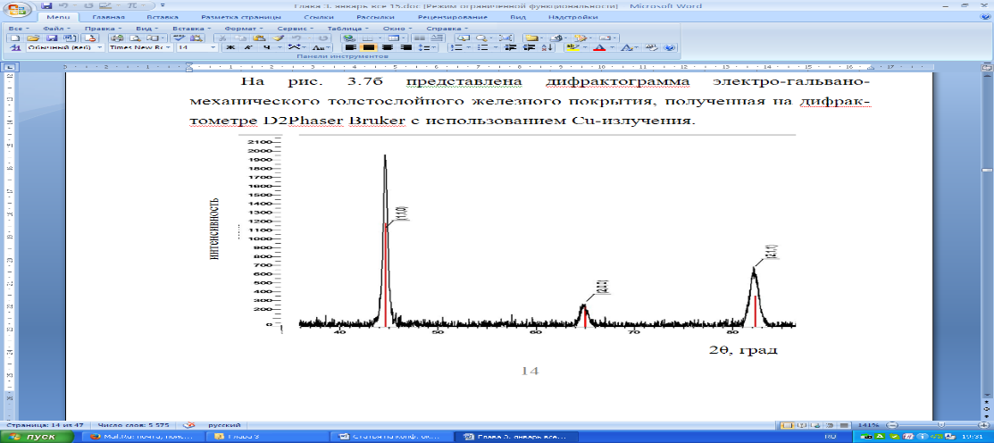

Fig. 1. The name of the picture

Explanations to Table 1.
Table 1
Name of table 1

1 | 2 | 3 | 4 | 5

Literature

1. Hamburg, V. N.Yu. N. Hydrogen. Properties, preparation, storage, transportation, application: Reference ed. / J.Y. N. Hamburg, V. N.P. N. Semenov, N.F. N. Dubovkin, L. N.N. Smirnov; edited by N. According to J.Y. N. Hamburg, N.F. N. Dubovkina, M. N.: Khimiya, 1989, 672 p. ill.

¹Federal State Budgetary Educational Institution of Higher Education «Voronezh State Technical University»
²Serbian Royal Academies of Sciences, Belgrade, Serbia

Appendix 3

PRESENTATION DESIGN

The best presentations of the reports will be awarded with diplomas, and participation will be marked with a certificate at the request of the authors. An online presentation is provided (a remote E-presentation – from 5 to 15 slides in Russian and/or English – is available in free form in pdf/ppt format).
The language of the presentation is chosen by the participants (Russian or English).

EXAMPLE OF PRESENTATION DESIGN

1 slide.

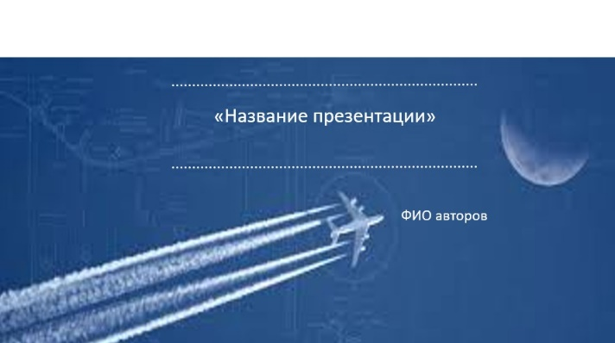

2 slide.

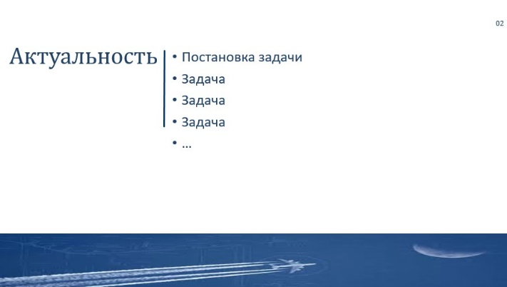

Slide 3.

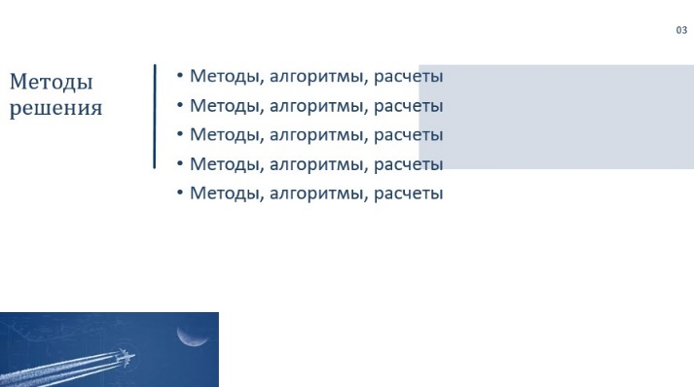

Slide 4.

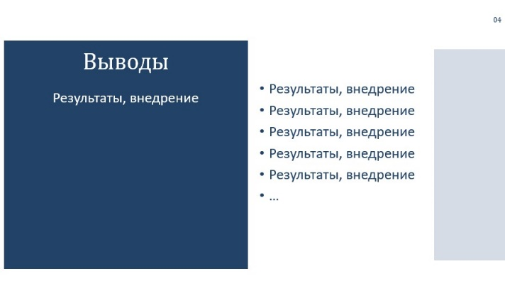
Slide 5.



*It is allowed to make a presentation without using the recommended template in pdf/ppt.

